Deconstruct the still image by filling in the boxes surrounding it. Make sure to write detailed annotations that describe each of your image’s symbolic, written and technical codes.
Symbolic Codes (setting, objects, colour, body language and facial expressions, shapes)
Identification of symbolic code  Colour:  Objects:  Setting:  Clothing:  Body Language: |  | Effect of symbolic code
Written Codes (headlines, captions, size and font)  Are certain words highlighted/bigger or smaller?  Do the words used reflect the context?  Why are the words included in this image? | 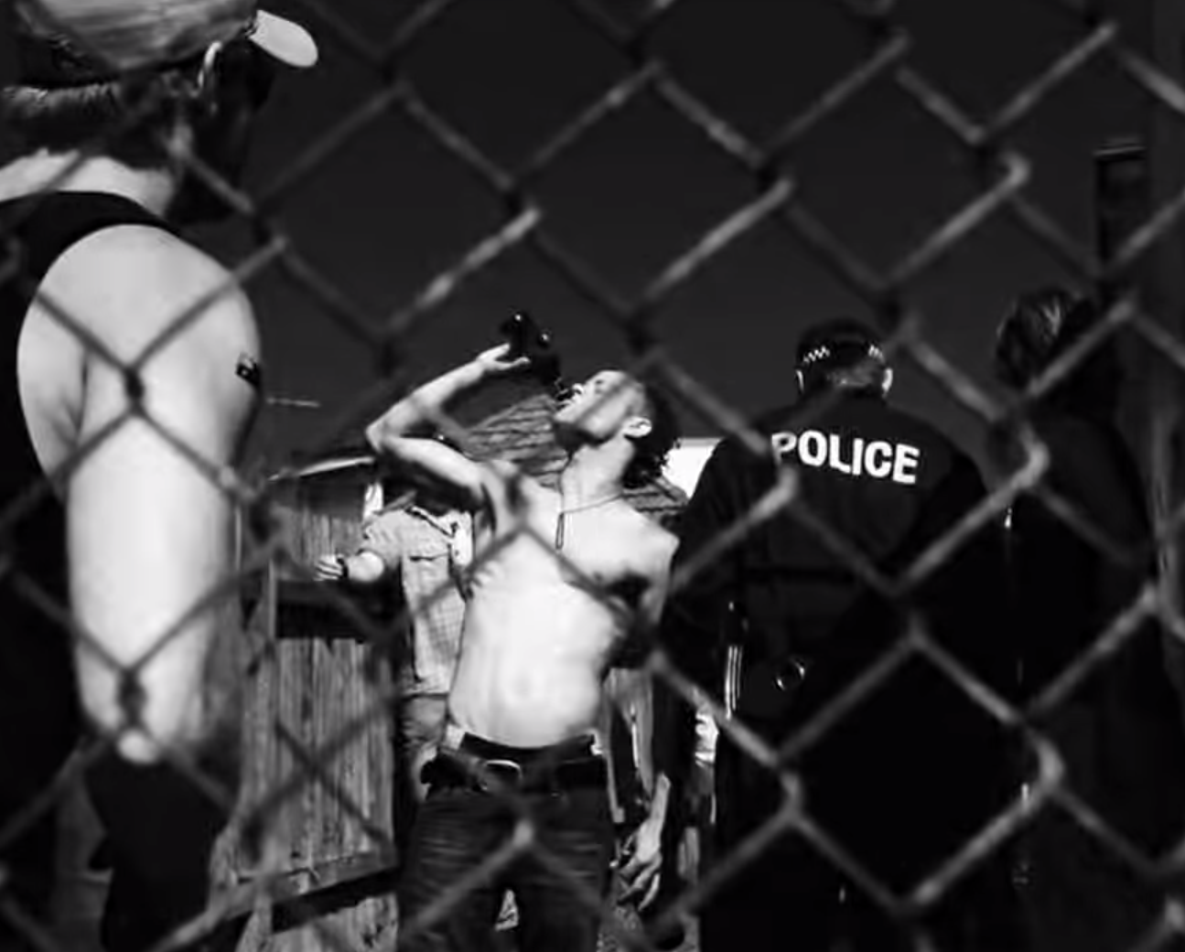 |  | Technical Codes  (camera angles, shot type, framing and composition)  What is included/excluded?  Focal Point:  Focus/Blurring:  Camera distance:
What do you think the message of this image is? Why? Discuss the visual elements in the image to support your answer.

